ARCHITHA OJHA
2303A52170 – 41

Security Testing: Identifying Vulnerabilities in AI- Generated Code

Task 1 – Password Strength & Validation Check
Task:
Analyze an AI-generated user registration script for weak password
handling.
Instructions:
• Prompt AI to generate a Python user registration program
• Check whether:
o Password length is validated
o Weak passwords are allowed
• Suggest secure improvements such as:
o Minimum length checks
o Use of regular expressions
o Rejecting common passwords
Expected Output:
A secure registration script with strong password validation rules.

Prompt: "Generate a Python user registration function that validates passwords using length checks, complexity requirements via regex, and a blacklist of common passwords."

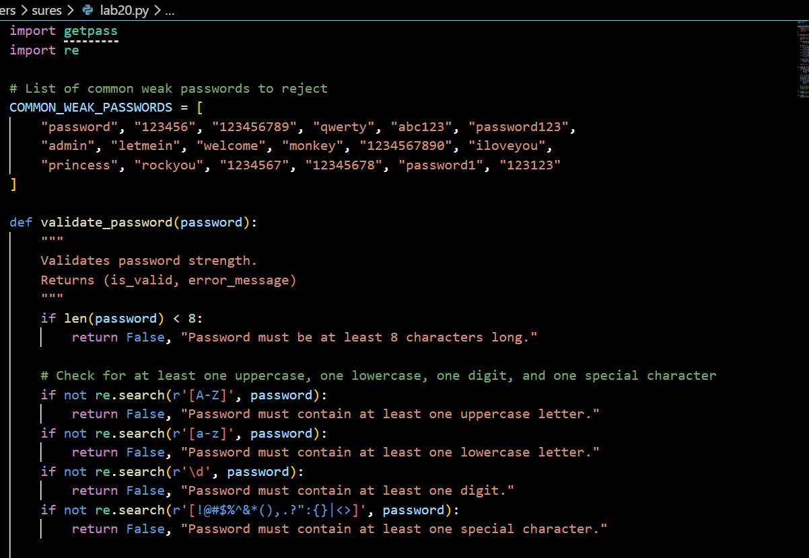
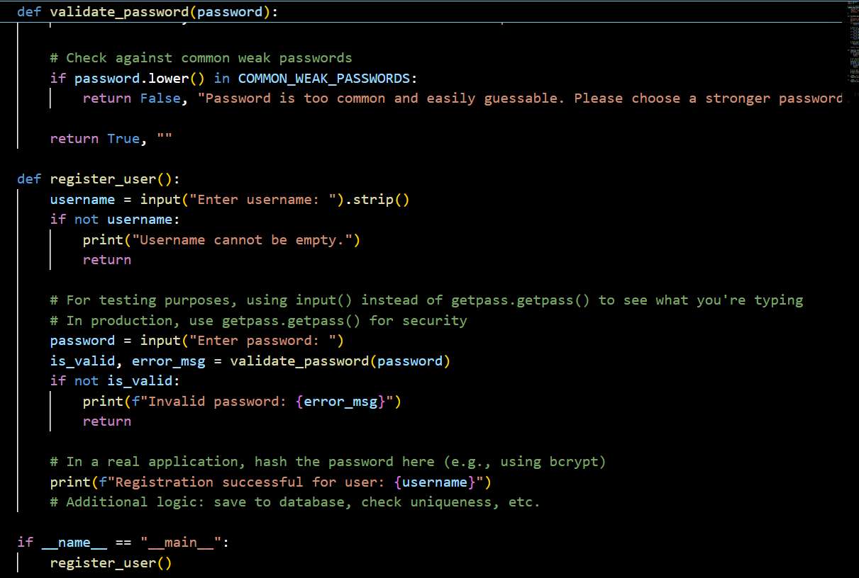
OUTPUT:
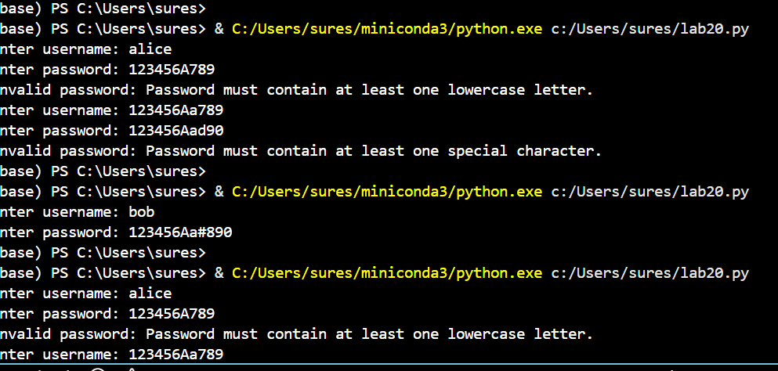
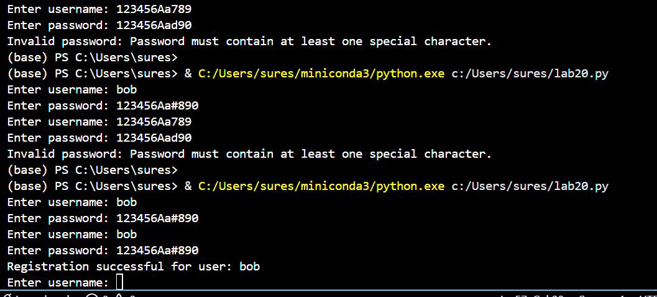

Justification: AI often defaults to simple if len(password) > 5 checks. This prompt forces the inclusion of entropy (special characters/numbers) and protects against credential stuffing by rejecting common passwords like "123456" or "password."

Task 2 – Insecure File Upload Handling
Task:
Evaluate an AI-generated file upload program for security risks.
Instructions:
• Prompt AI to generate a Python or Flask-based file upload
script
• Identify vulnerabilities such as:
o No file type validation
o Unrestricted file size
• Implement secure measures:
o File extension validation
o Size limits
o Safe file storage paths
Expected Output:
A secure file upload implementation that prevents malicious
uploads.
Prompt: "Create a Flask file upload script that enforces strict file extension whitelisting, limits file size to 2MB, and uses secure_filename for storage."

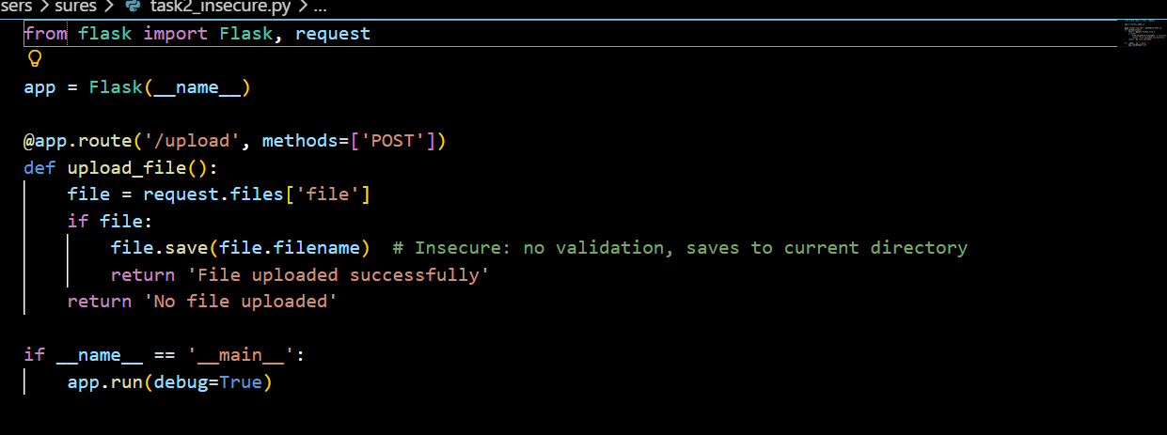

OUTPUT:
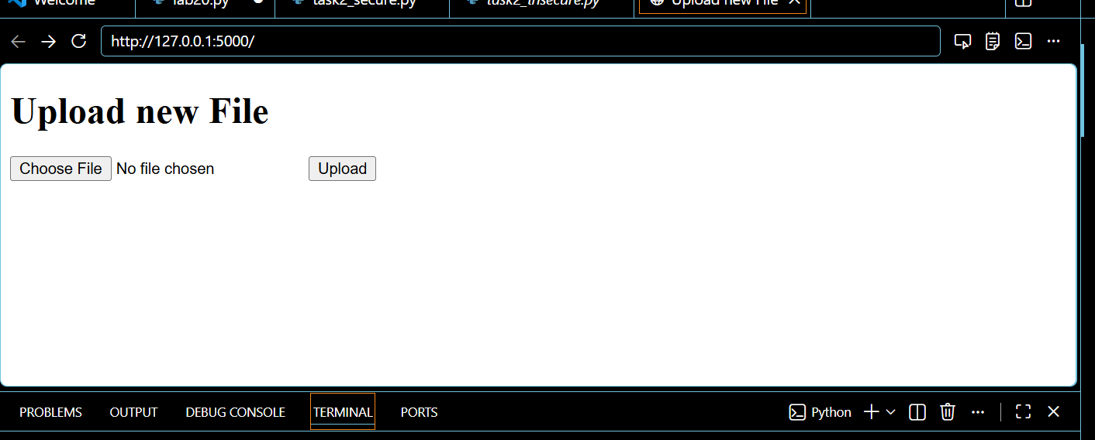

Justification: Default AI scripts often allow any file type, leading to Remote Code Execution (RCE) if an attacker uploads a .php or .py script. This approach mitigates risk through validation and path sanitization.

Task 3 – Real-Time Application: API Security Review
Scenario:
An AI-generated API endpoint is used in a web application.
Instructions:
• Review the API code for:
o Missing authentication
o Insecure HTTP methods
o Lack of rate limiting
• Prompt AI to suggest security improvements such as:
o Token-based authentication
o Input validation
o Rate limiting
Expected Output:
A security-reviewed API endpoint with documented vulnerabilities
and fixes.
Prompt: "Refactor a Flask API endpoint to include Bearer Token authentication, input validation using Marshmallow, and a 10-requests-per-minute rate limit."
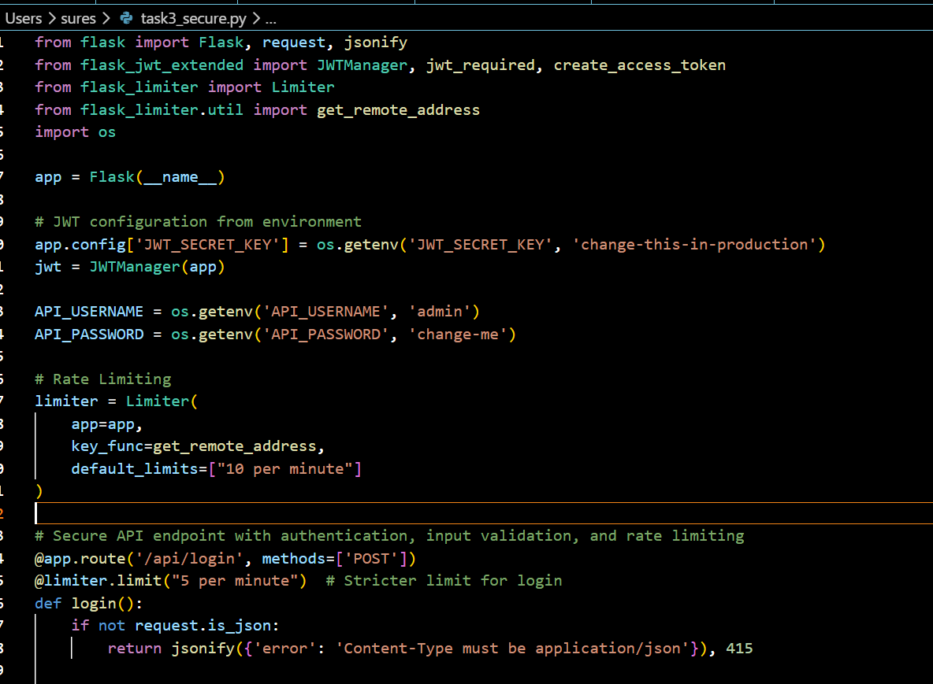
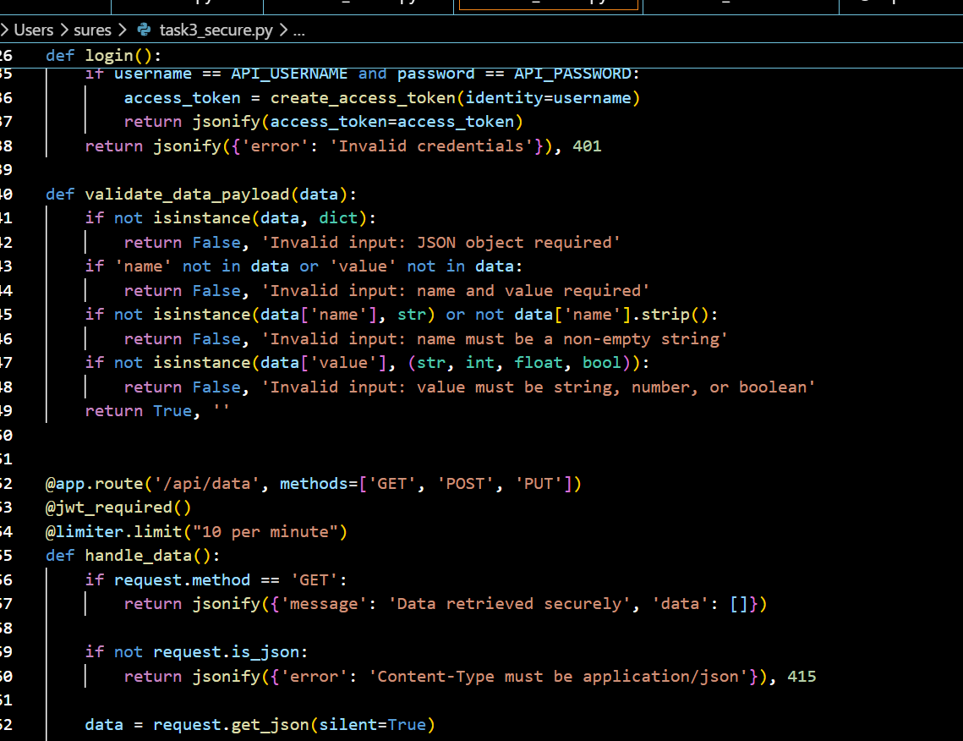
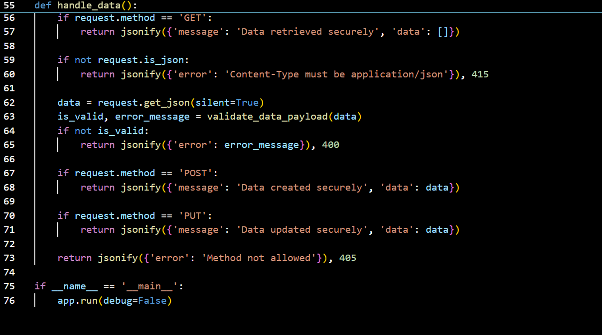

OUTPUT:

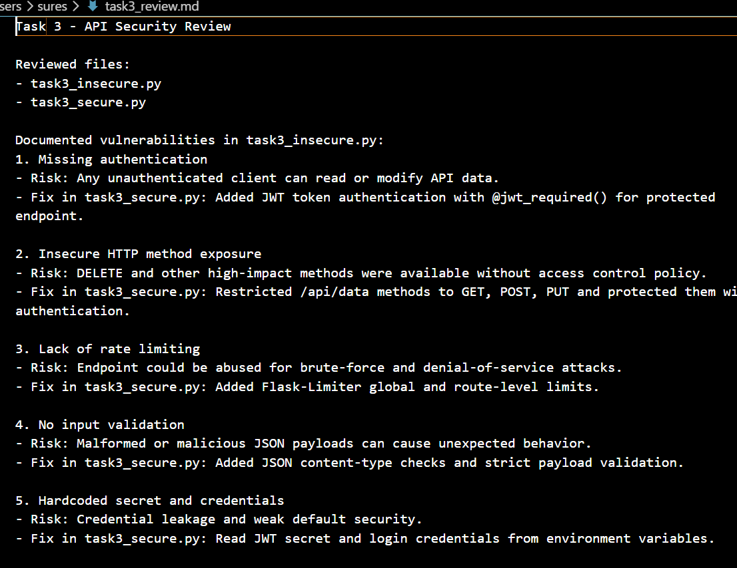
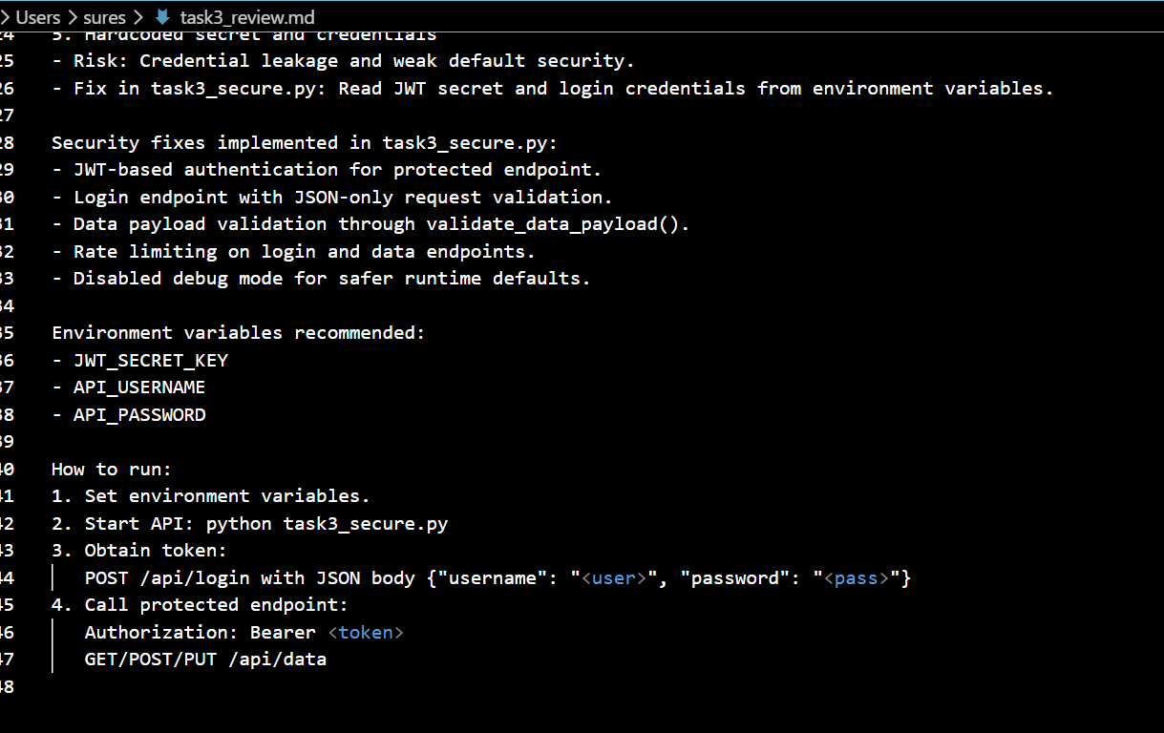

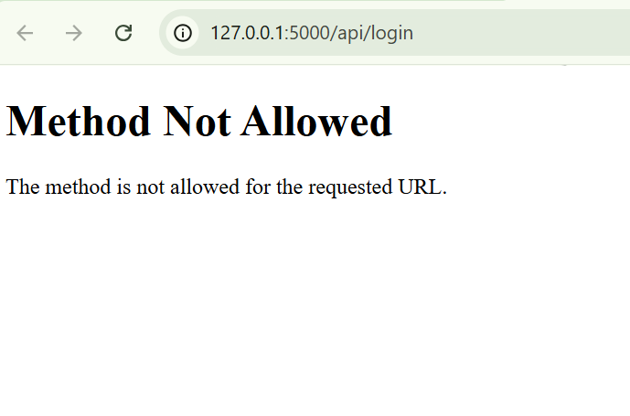
Justification: Basic AI endpoints often lack authentication, leaving data exposed. Adding rate limiting prevents Brute Force and DoS attacks, while token-based Auth ensures only authorized users access the resource.

Task 4 – Cross-Site Scripting (XSS) Check
Task:
Evaluate an AI-generated HTML form with JavaScript for XSS
vulnerabilities.
Instructions:
• Ask AI to generate a feedback form with JavaScript-based
output.
• Test whether untrusted inputs are directly rendered without
escaping.
• Implement secure measures (e.g., escaping HTML entities,
using CSP).
Expected Output:
• A secure form that prevents XSS attacks.

Prompt: "Create a feedback form where JavaScript output is sanitized using textContent instead of innerHTML to prevent XSS."

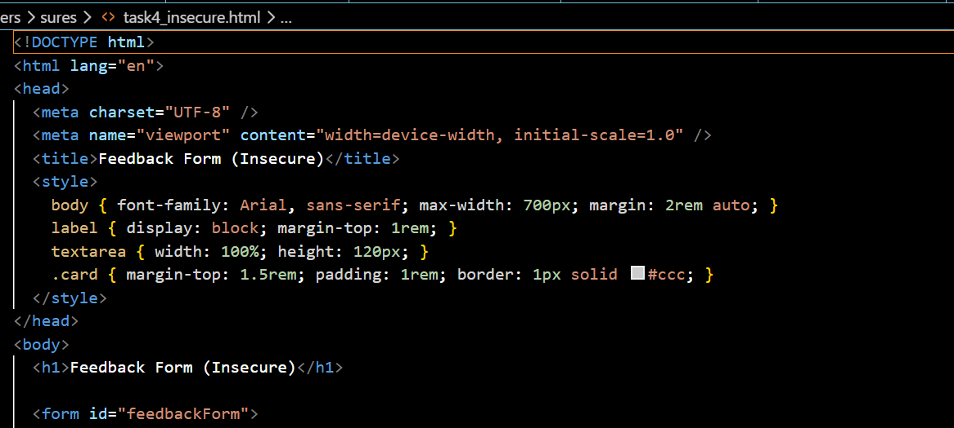
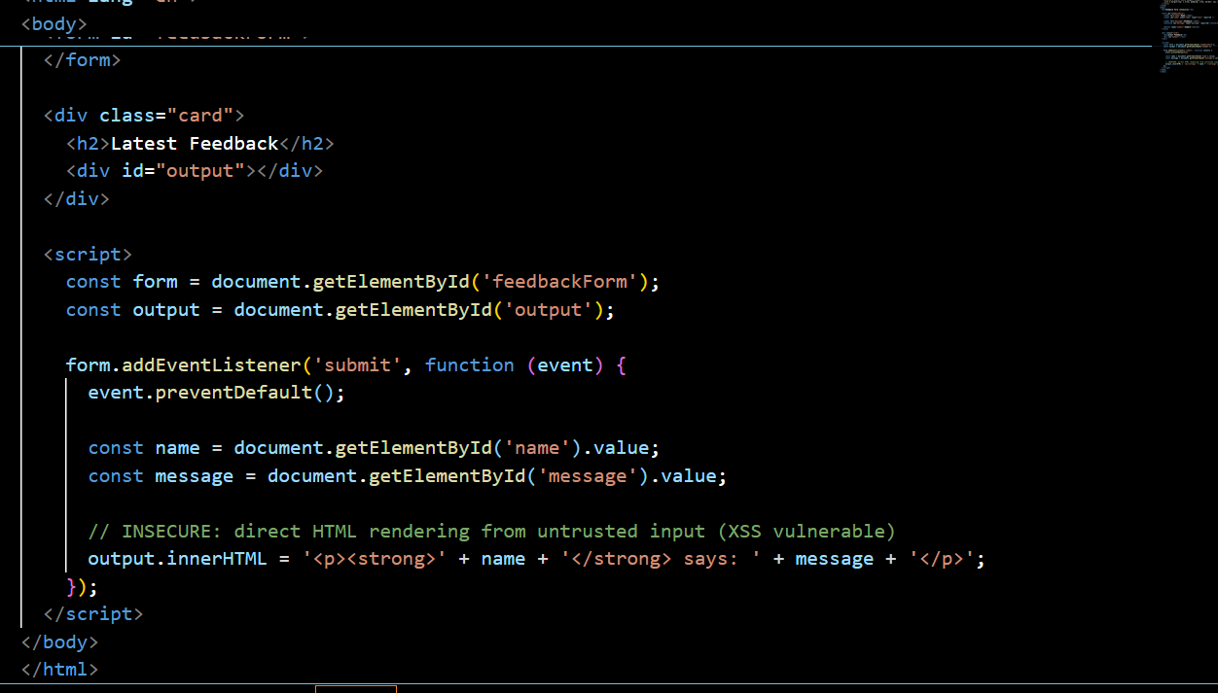
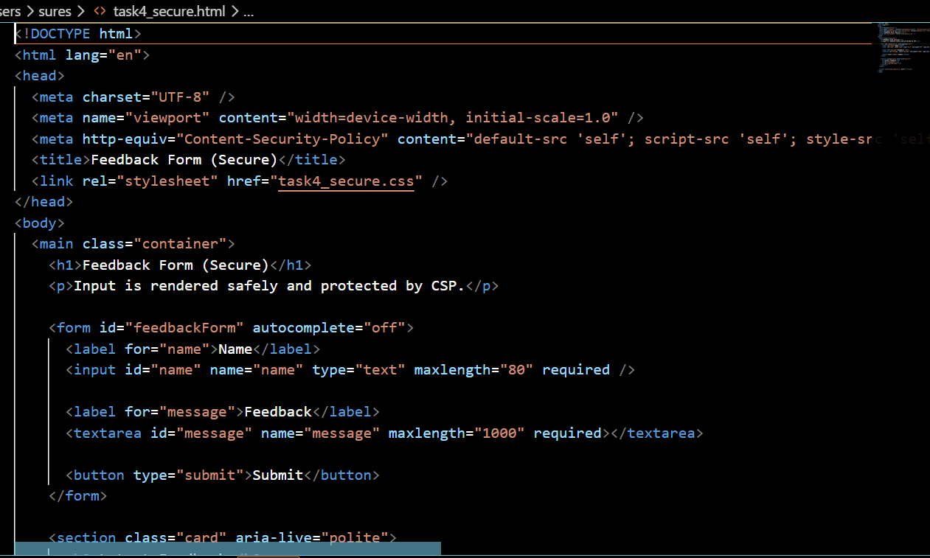
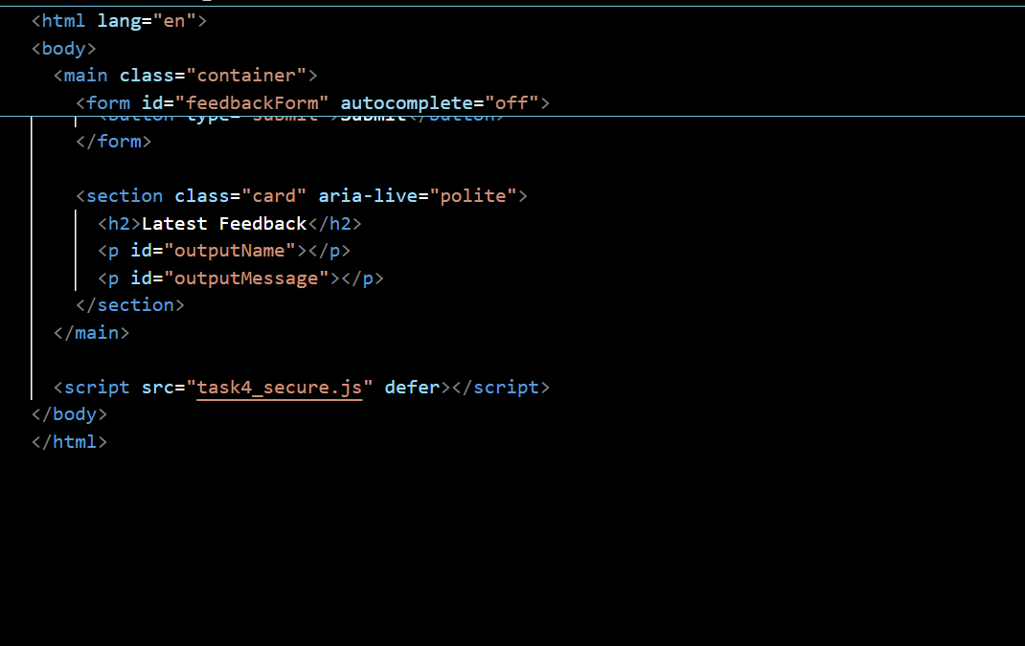
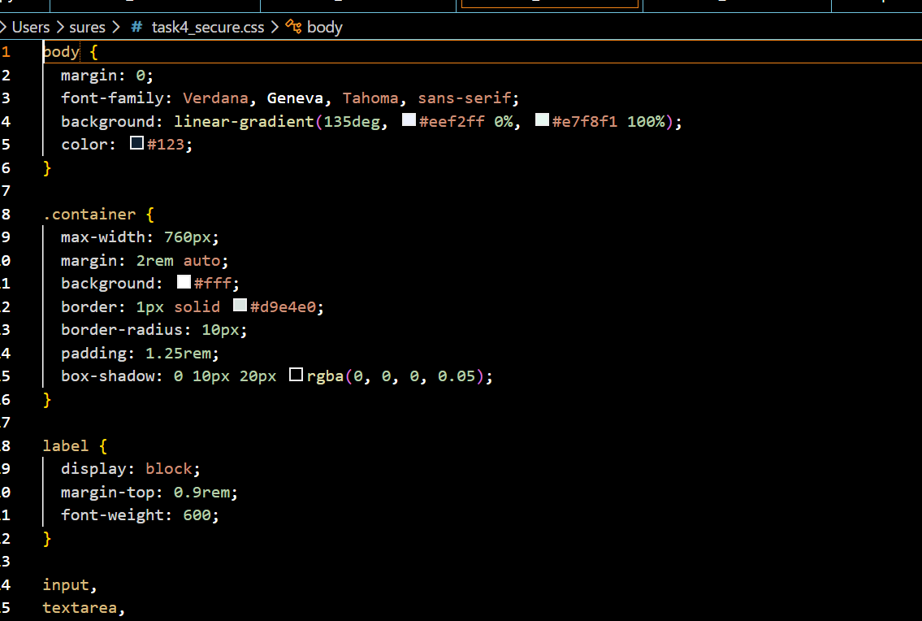
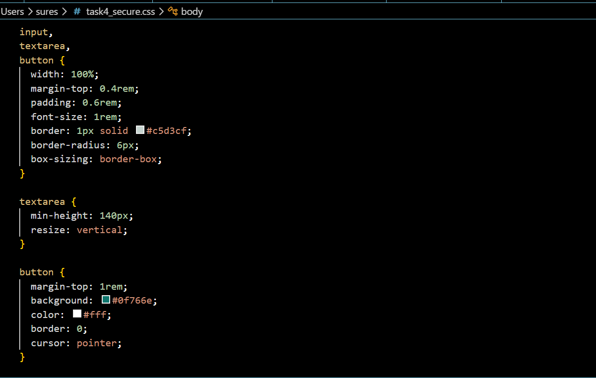
OUTPUT:

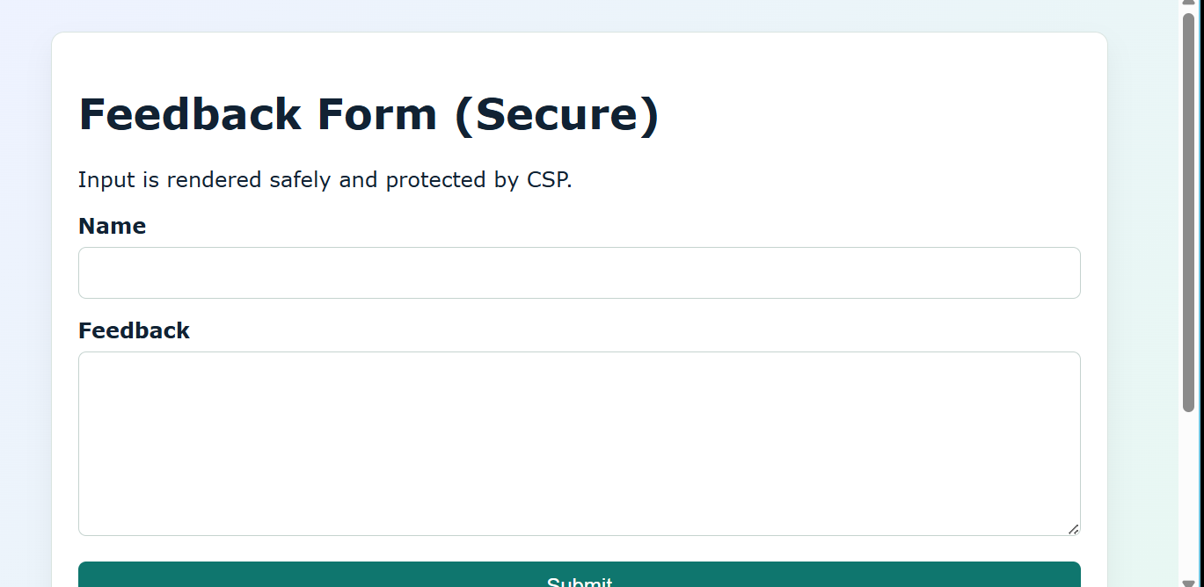
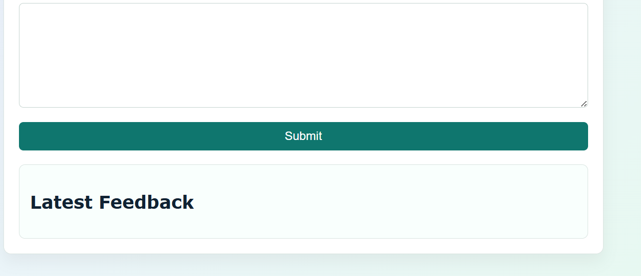
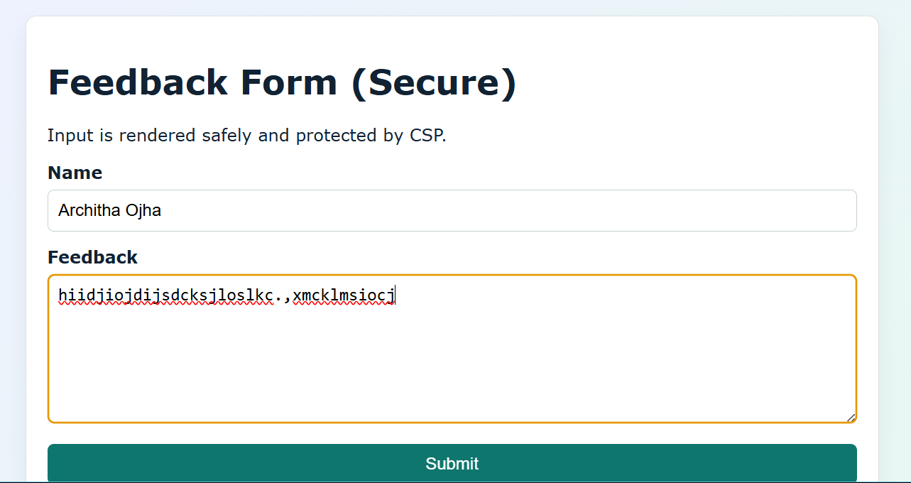
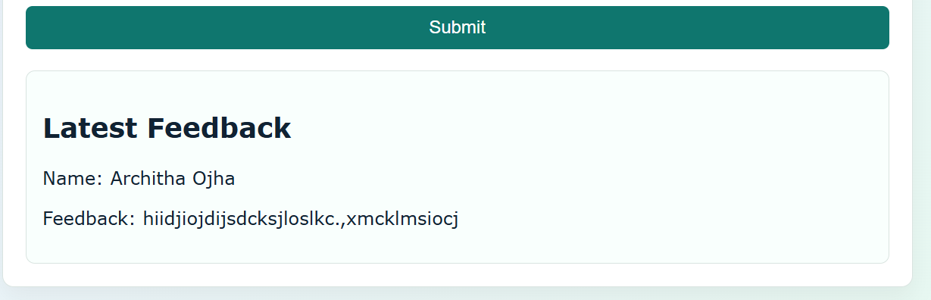

Justification: Directly inserting user input into innerHTML allows attackers to execute malicious scripts. Using textContent ensures the browser treats input strictly as text, not executable code.

Task 5 – SQL Injection Prevention
Task:
Test an AI-generated script that performs SQL queries on a
database.
Instructions:
• Ask AI to generate a Python script using SQLite/MySQL to
fetch user details.
• Identify if the code is vulnerable to SQL injection (e.g.,
using string concatenation in queries).
• Refactor using parameterized queries (prepared
statements).
Expected Output:
• A secure database query script resistant to SQL injection.

Prompt:
"Generate a Python SQLite script that fetches user details using parameterized queries instead of f-strings or string formatting."
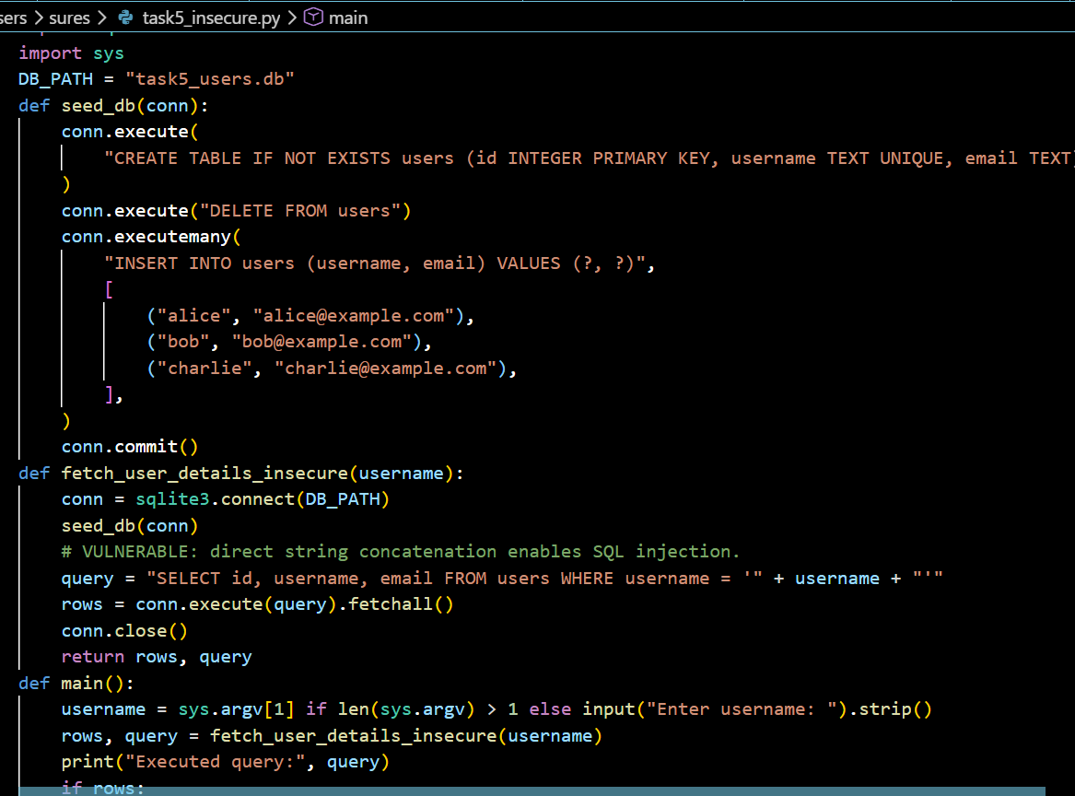
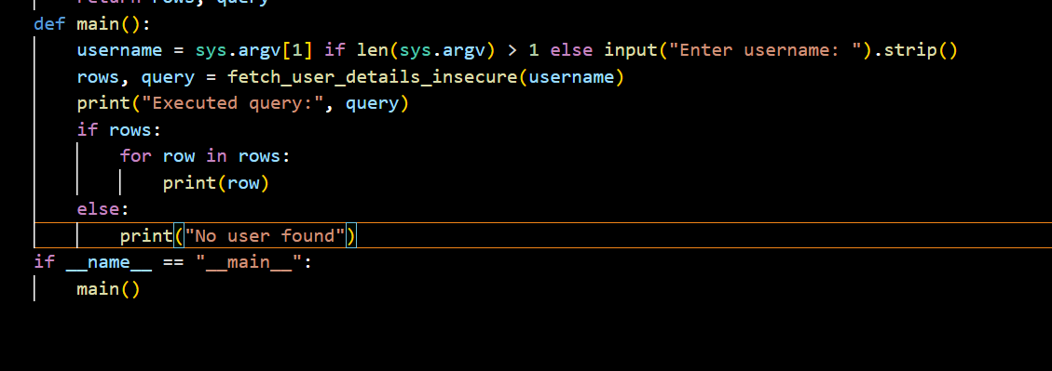
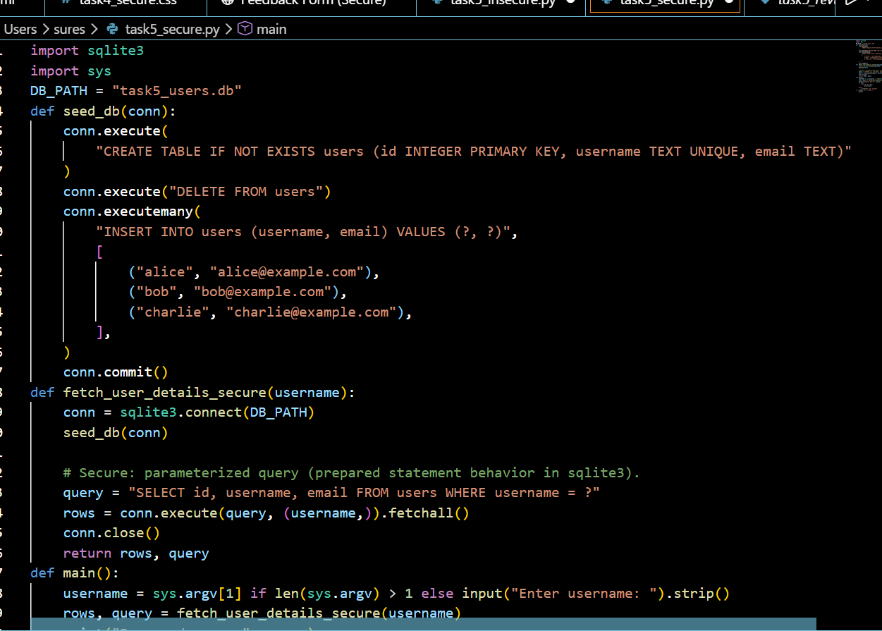
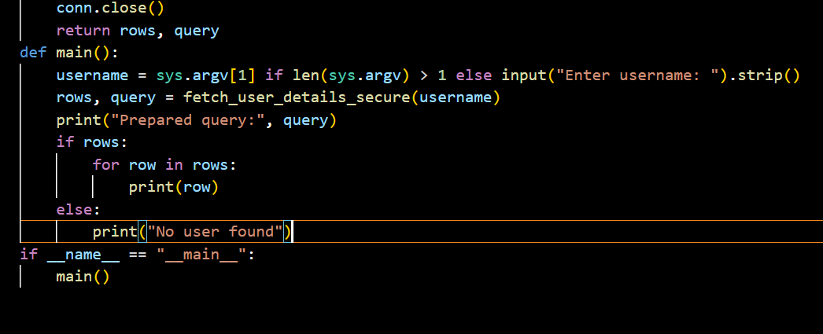
OUTPUT:

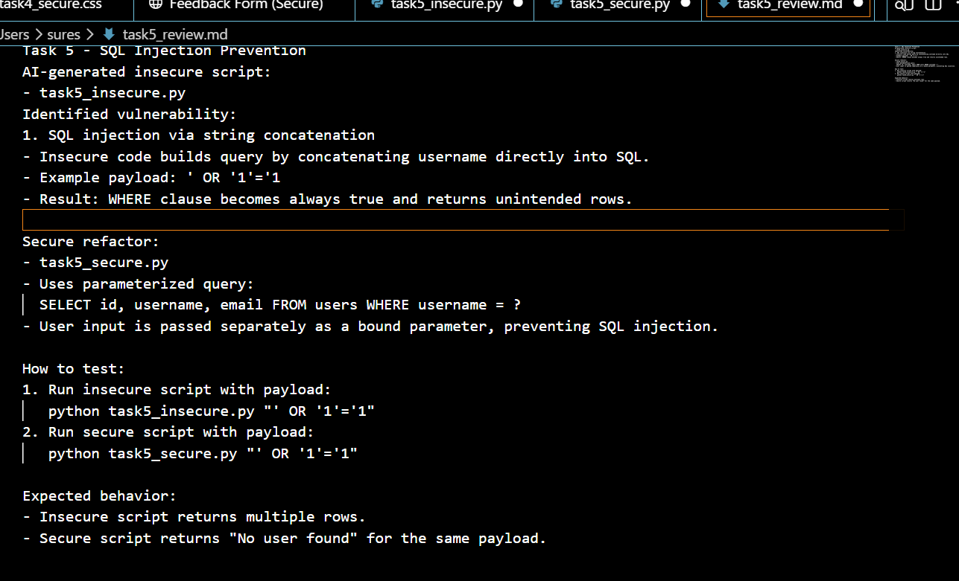
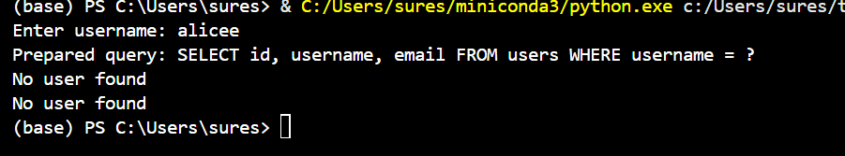
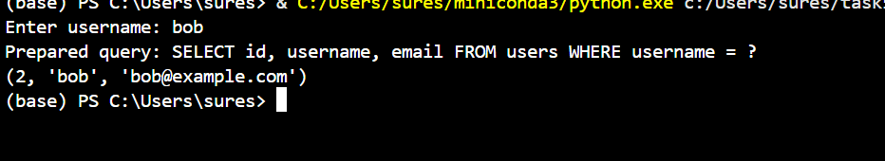
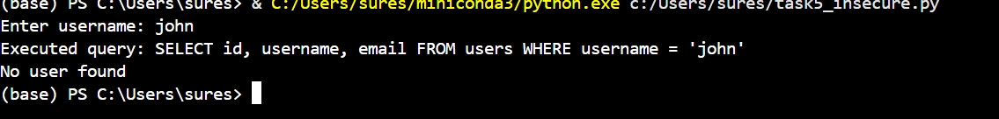

Justification: String concatenation allows an attacker to "break out" of a query (e.g., ' OR '1'='1). Parameterized queries send the command and the data separately, making injection impossible.

